The Harvard University Retirees Association
Invites you to a tour and discussion of the
African Meeting House and the
Museum of African American History
46 Joy Street, Beacon Hill, Boston

Thursday, November 12, 2026, 10:30 to 12:00 noon
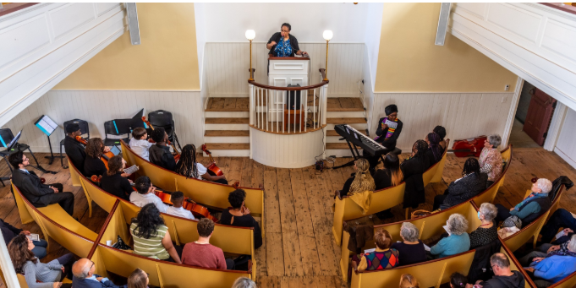
During this 90 minute private tour, we will view the Abiel Smith Schoolhouse (1835), the oldest public school in the United States, built for the sole purpose of educating African American children. We will also tour the African Meeting House (1806), the oldest extant black church building in the nation. HURA members will be able to participate in an in-depth discussion about the history and the self-determination of Boston's free Black community in the 19th century.
Please note that this tour involves navigating Joy Street's somewhat steep incline.

The event will take place rain or shine. Lunch is on your own; a list of nearby restaurants and a description of transportation options will be sent to those who register.

______________________________________________________________________________

Register using this Eventbrite link regardless of
method of payment
https://MAAHHura.eventbrite.com

_____________________________________________________________________________
Registration fee $10.
_______________________________________________________________________________

This group tour for 30 persons will visit the African Meeting House, which is operated by the Museum of African American History. It was built in 1806 and first served as the African Baptist Church of Boston. It is considered the oldest extant Black church building in America. In addition to serving as a spiritual and religious center for the community, the African Meeting House provided an integral gathering space for the cultural, educational, and political life of Boston’s Black community.

The African Meeting House is the principal historic building on the Boston campus of the Museum of African American History. The Museum of African History, the legal name of the organization, is quite often identified as MAAH, its initials. The African Meeting House is a National Historic Landmark and along with the Abiel Smith School constitute the properties on the Boston campus of MAAH which also has historic buildings on Nantucket.
Jamie

